|  |  |
| --- | --- |
| **Dimensioning Data (Network)** | To be defined by Dhaval, Falk, ISY..  Electrical relation only:   * Electrical devices (MCCB); * Characteristics (250Amp); * Functions (outgoing); * Linking information between components. |
| **Frontview (inside view)** | **Frontview with Door** |

**Sales Item Structure:**

Transformer

Cable

Switchboard

Switchboard BOM

BOM Sales Item1

…

Cubicle1 (ACB)

Cubicle BOM

Frame

Door (with custom cuttings for Metering)

Horizontal Busbar

Vertical Busbar

Device connection busbar

**Device1 (ACB)**

Device1 BOM

Real Breaker device (supplier specific)

Current Transformer CT1

Current Meter (Door Link)

Device2

Device3

Spare

Cubicle2 (MCCB)

BOM

Device4 (MCCB)

Device5

Device6

Spare

Spare

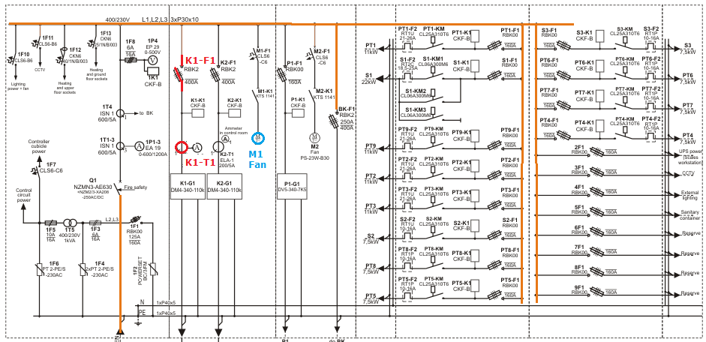

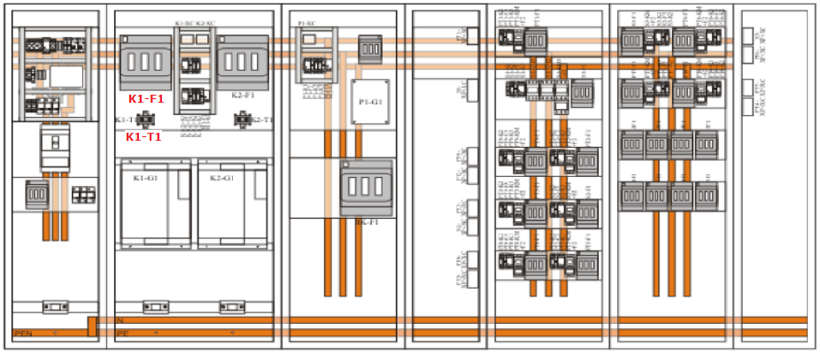

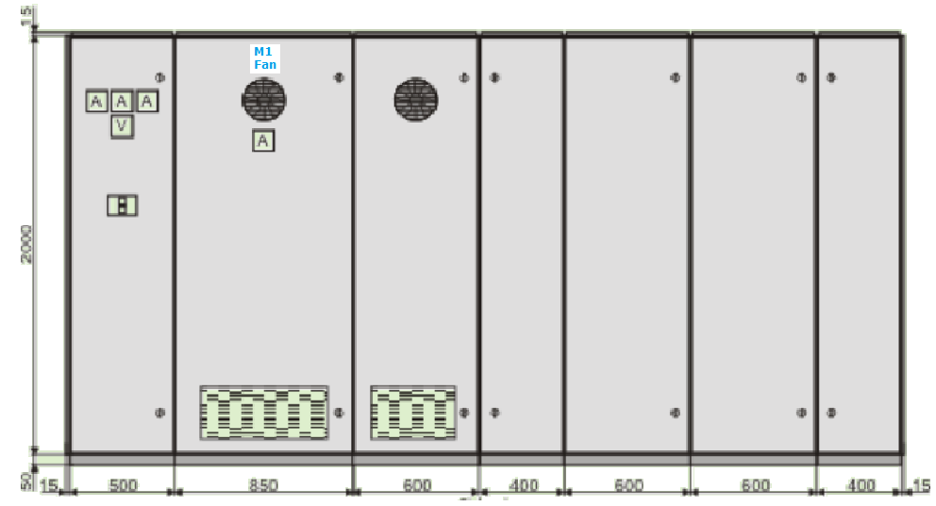

<http://zpue.pl/en/low-voltage-switchgear/instal-blok/examples-of-switchgear.html>

Electrical Vierw Frontview Inside view

with Door without Busbar

